Jay was in charge of completing the Parallel Programming task for this assignment, but due to a miscommunication he was unable to obtain the Pi in order to complete the the task. Bonnie, Marcus, and Jacques completed the task and communicated the process and results to the other team members.

Initially, we simply copied the code provided in the document into the terminal and then wrote and linked it, but we realized that we were unfamiliar with the code and commands or even what it was trying to accomplish. We then went back to the top of the document and read over the tips that it lists before the code, and then went over the code line by line and attempted to figure out what the commands meant before running. We quickly looked over the diagram but it was a little hard to make sense of it so we skipped it.

Finally, we ran the code with the ./spmd2 4 command. We hadn’t read ahead so when it printed out in the wrong order and repeating threads we got confused and thought we had done something wrong. However, we read ahead when we couldn’t figure out what was wrong and saw that it was meant to be that way.

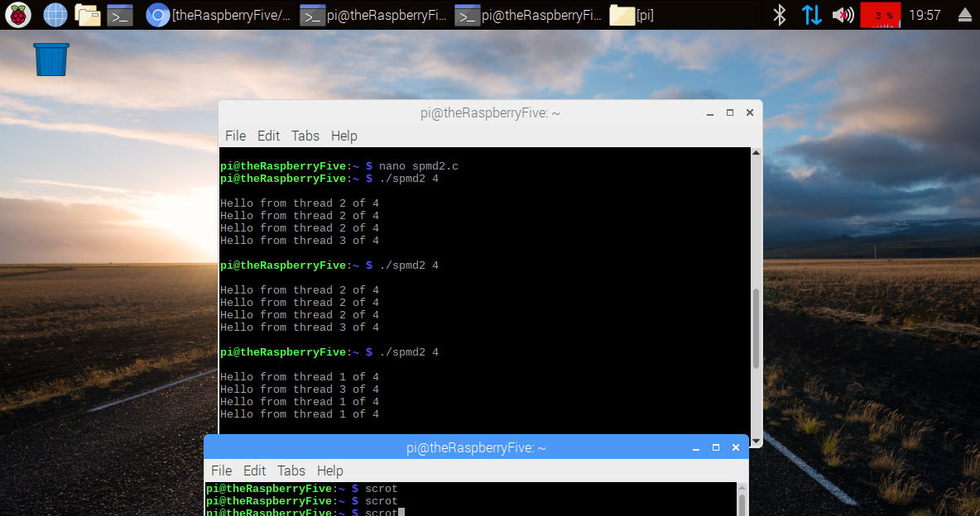

We then read the instructions and corrected the code.

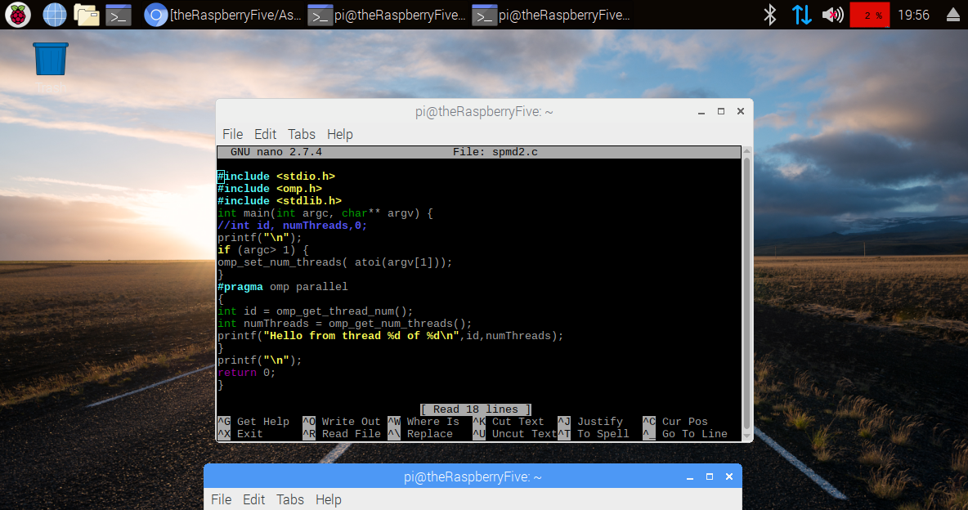

We saved and exited again and tried to run the code but we forgot to call the “gcc spmd2.c -o spmd2 -fopenmp” command again to create the executable file. Because of this, our code kept printing with repeating strings and we had trouble figuring out why. However, after checking our code several times, we eventually decided to type out every instruction again just to be sure we had it right. After doing this the code ran correctly, and we were able to observe output that did not repeat strings, although it did print in incorrect order.

